**Complete the code for the Solar System**

**201133216**

**정유석**

Simulate the sun, moon  and eight planets of the solar system.

Represent full revolution  of each planet around the sun by different speed.

Represent a revolution of the moon around the earth.

ScreenShot

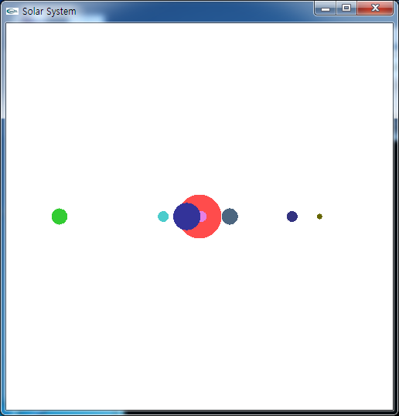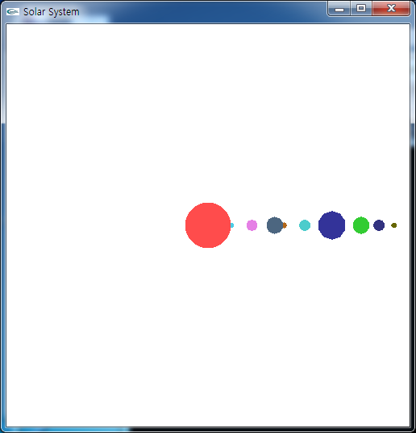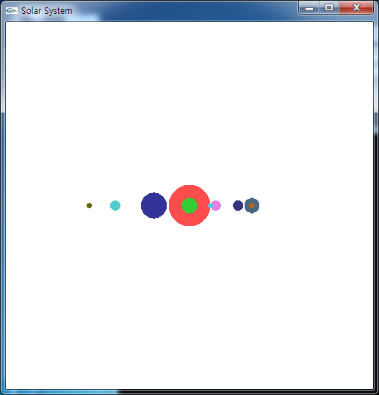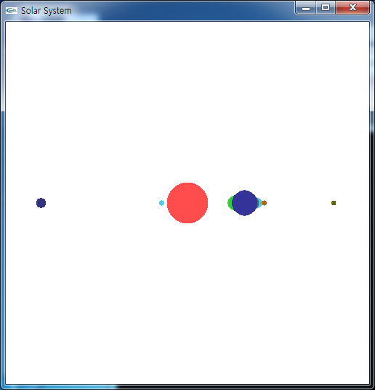

CODE

#include <stdlib.h>

#include <time.h>

#include <gl/glut.h>

static int delay = 150; //Delay time

static int Su = 0, Geom = 0, Ji_Day = 0,Ji_Time=0, Hwa = 0, Mok = 0, To = 0, Cheon = 0, Hae = 0;

void MyDisplay() {

glOrtho(-0.7, 0.7, -0.7, 0.7, -0.7, 0.7); //Set size of the 3-dimensional

glEnable ( GL_DEPTH_TEST );

glClear(GL_COLOR_BUFFER_BIT | GL_DEPTH_BUFFER_BIT); //Clear color buffer and Dpeth buffer

glMatrixMode(GL_MODELVIEW); //Set modelview

glLoadIdentity(); //Set C (It use calculation of transformation)

//Draw the Sun

glColor3f(1.0, 0.3, 0.3);

glutSolidSphere(0.08, 20, 16);

//Draw the Mercury

glRotatef((GLfloat)Su, 0.0, 1.0, 0.0); //Rotation to itself

glTranslatef(0.1, 0.0, 0.0); //Transition to 0.1

glColor3f(0.3, 0.8, 0.9); //Set color

glutSolidSphere(0.01, 10, 8); //Draw sphere

//Draw the Venus

glLoadIdentity(); //Set the first position(sun)

glRotatef((GLfloat)Geom, 0.0, 1.0, 0.0);

glTranslatef(0.17, 0.0, 0.0);

glColor3f(0.9, 0.5, 0.9);

glutSolidSphere(0.02, 10, 8);

//Draw the Earth

glLoadIdentity(); //Set the first position(above same)

glRotatef((GLfloat)Ji_Day, 0.0, 1.0, 0.0);

glTranslatef(0.25, 0.0, 0.0);

glRotatef((GLfloat)Ji_Time, 0.0, 1.0, 0.0);

glColor3f(0.3, 0.4, 0.5);

glutSolidSphere(0.03, 10, 8);

glPushMatrix(); //It push now position because Represent a revolution of the moon around the earth.

//Draw the moon

glRotatef((GLfloat)Ji_Time, 0.0, 1.0, 0.0);

glTranslatef(0.05, 0.0, 0.0);

glColor3f(0.7, 0.4, 0.1);

glutSolidSphere(0.01, 10, 8);

glPopMatrix(); //because it set the first(Sun) position

glLoadIdentity();

//Draw the Mars

glRotatef((GLfloat)Hwa, 0.0, 1.0, 0.0);

glTranslatef(0.35, 0.0, 0.0);

glColor3f(0.3, 0.8, 0.8);

glutSolidSphere(0.02, 10, 8);

//Draw the Jupiter

glLoadIdentity();

glRotatef((GLfloat)Mok, 0.0, 1.0, 0.0);

glTranslatef(0.44, 0.0, 0.0);

glColor3f(0.2, 0.2, 0.6);

glutSolidSphere(0.05, 10, 8);

//Draw the Saturn

glLoadIdentity();

glRotatef((GLfloat)To, 0.0, 1.0, 0.0);

glTranslatef(0.54, 0.0, 0.0);

glColor3f(0.2, 0.8, 0.2);

glutSolidSphere(0.03, 10, 8);

//Draw the Uranus

glLoadIdentity();

glRotatef((GLfloat)Cheon, 0.0, 1.0, 0.0);

glTranslatef(0.6, 0.0, 0.0);

glColor3f(0.2, 0.2, 0.5);

glutSolidSphere(0.02, 10, 8);

//Draw the Neptune

glLoadIdentity();

glRotatef((GLfloat)Hae, 0.0, 1.0, 0.0);

glTranslatef(0.65, 0.0, 0.0);

glColor3f(0.4, 0.4, 0);

glutSolidSphere(0.01, 10, 8);

glutSwapBuffers();//Swap background buffer

}

void timer(int t){

//Represent Each planet around the sun by different speed.

Su = (Su + 18) % 360;

Geom = (Geom + 13) % 360;

Ji_Day = (Ji_Day + 11) % 360;

Ji_Time = (Ji_Time + 7) % 360;

Hwa = (Hwa + 8) % 360;

Mok = (Mok + 6) % 360;

To = (To + 5) % 360;

Cheon = (Cheon + 4) % 360;

Hae = (Hae + 3) % 360;

glutPostRedisplay(); //Dispaly function call.

glutTimerFunc(delay, timer, t);

}

int main(int argc, char** argv) {

glutInit(&argc, argv);

glutInitDisplayMode(GLUT_DOUBLE | GLUT_RGB | GLUT_DEPTH);

glutInitWindowSize(500, 500);

glutInitWindowPosition(0, 0);

glutCreateWindow("Solar System");

glMatrixMode(GL_PROJECTION);

glClearColor(1.0, 1.0, 1.0, 1.0);

glutTimerFunc(delay, timer, 0);

glutDisplayFunc(MyDisplay);

glutMainLoop();

return 0;

}